GENERAL INSPECTION OF ROAD LEVEL CROSSINGS
Applicability – Road level crossings of all protection type – Track, Civil and Signage equipment
Refer to ETS-12-00 for Inspection and Assessment details.
Location: Equipment No.:
Kilometrage: Date: Work Order:
Maintenance boundaries varies across states (circle answer):
NSW | QLD | SA | VIC | WA
For public crossings, the maintenance boundaries below are reference only and vary based on the individual State requirements (from the outer rail):
QLD | NSW | VIC | SA | WA
0.6 m | 1 m | 3 m | 1 m | 3 m
For private crossings, maintain road to railway corridor (boundary fence or up to 15m), unless otherwise stated in individual level crossing license / agreements where applicable.

Type of level crossing being inspected (circle answer in each box):
ARTC only  Multi RIMs Shared Level Crossing | Passive Level Crossing  Active Level Crossing | Public Level Crossing  Private Level Crossing  Service Level Crossing

Sighting
Element | Observed Result | General Response | Comments
Sighting Obstructions  Sighting distance not obscured by track side stockpiles, vegetation etc. |  | Remove where obstructions present in the rail corridor and liaise with the road manager (i.e. council or landowner) where the obstruction is outside the rail corridor.  Contact Engineering team if further assessment is required for remediation

Signs
Element | Observed Result | General Response | Comments
Obstructions  Obstructions to control signs (stop/give way) to road users |  | Remove obstruction if within Maintenance Boundary, inform road manager otherwise.
Sign Condition  Sign is present not missing any assemblies (see reference), free of graffiti, and not faded etc |  | Repair or replace signs.  Any observations outside rail corridor – Record and notify Road Manager
Sign Missing |  | If missing the Stop or Give Way sign, implement necessary measures such as CAN warning and restricting access subject to site risk. 20km/h TSR until sign is replaced.

Civil
Element | Observed Result | General Response | Comments
Gauge  (Different restrictions apply based on track speed; look for signs of gauge widening or tightening) |  | Record any defects as Known Conditions and respond as per Track and Civil Response Booklet
Sleepers and Fastening  Missing Sleepers (where visible)  Ineffective sleepers or fastenings (where visible) |  | Record any defects as Known Conditions and respond as per Track and Civil Response Booklet
Rail Condition  Check condition of rail head. Look for RCF, Shelling, Squats, Wheel burns, Rail flow, Corrosion and Mechanical damage etc. |  | Record any defects as Known Conditions and respond as per Track and Civil Response Booklet
Track Geometry  Visual check for Ballast degradation, heave, Mud hole development, Top & Twist etc |  | Record any defects as Known Conditions and respond as per Track and Civil Response Booklet
Flangeway |  | Width > 85mm record as Known Condition  Width < 60mm –  remediation required within 28 days  Depth < 40 mm – remediation required within 28 days
Sealed Crossing Surface  Pothole / deformation depth (measured with a 1 m straight edge) |  | 20 mm to 40 mm - Monitor condition or repair within 180 days  40 mm to 60 mm – Repair within 90 days  >60 mm – Act as determined by site conditions and repair within 28 days
Modular Crossing Surface  Modular panel gaps >15mm posing hazard including to cyclist  Ineffective fastening system |  | Remediation required where defects present  Repair within 28 days
Modular Crossing Surface  Signs of wheel contact with crossing surface |  | Record as Known Condition
Unsealed Crossing Surface  Displacement of loose materials exposing rail head to road users |  | Remediation required where defects present  Repair within 28 days
Track Drainage (if applicable)  Look for evidence of pumping of the crossing  Check to ensure drainage path is clear and diverts water away from track |  | Record any defects as Known Conditions and respond as determined by site conditions
Vehicle Clearance  Check for drag marks or indications of road vehicles bottoming out on the approach and crossing surface. |  | Record observation.  Liaise with relevant party to investigate the cause and determine appropriate actions.
Barriers  Damaged barrier(s) at level crossing or around lx equipment |  | Record any defects as known conditions for repair were owned by ARTC, advice Road Manager for non-ARTC barriers.
Barriers  Lookout for non-frangible materials used for ARTC barrier / signs within 5m of the edge of the road  (e.g. Rail used as post) |  | Report as Known Condition for planned removal
Road Marking  Line faded etc. |  | Any observations – Record and notify Road Manager

Name of Inspector: Signature:

Sighting quadrants:
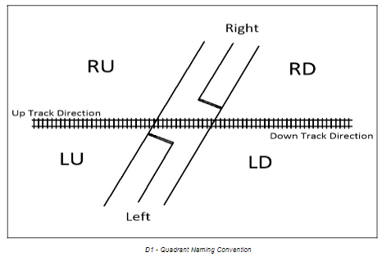

Acceptable replacement of RX-1, RX-2 and RX-5 assembly examples:

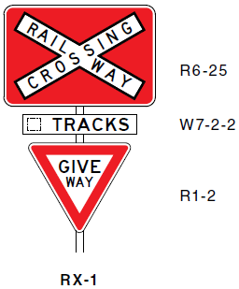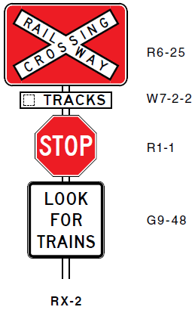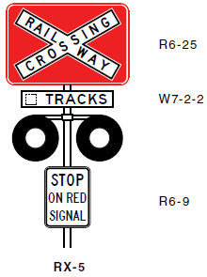

Figures reproduced from AS 1742.7:2016. © Standards Australia Limited 2022.

