<Project Name>
<Team Name> Plan
<Work Package Name>

<Date Issued>
<Revision>

Template Status
Discipline: | Engineering
Category: | Procedure - Template
Related Procedure: | EGP-20-01 Project Management
Template number: | EGW2001T-13 Team Plan
Date Reviewed: | 07 Jul 2015
Version: | 1.1

Contents
1 Work Package Definition 4
1.1 Work Package Responsibility 4
1.2 Objectives 4
1.3 Work Package Deliverables 4
1.4 Outline Work Package Delivery Strategy 5
2 Work Package Budget 6
3 Work Package Solution 7
3.1 Resource Summary 8
4 Work Package Risks 9

Document Control
Client: | Australian Rail Track Corporation
Project: | <Project Name>
Document Title: | <Team Name> Plan
Date Issued: | <Date Issued>
Revision: | <Revision>
Prepared by:
Purpose:
Endorsed by:
Approved by:
Date Approved:
Issued to:

Revision History
Revision | Date Issued | To | Description
1.0
2.0
3.0

Work Package Definition
General Comments about this template:
- This template should be used to define all elements of the work to be done by a particular team on a project
- For small projects it may not be necessary to use this template at all as there may be enough detail in the stage plan to allow for adequate controls to be put in place over the work being done by all teams. However for large projects where the work done by the teams is more significant it is sensible to develop a specific plan for that work.
If a Team Plan is produced it must be agreed between the Project Manager and the Team Leader/Manager and is then used as the basis of day-to-day control over the work being done by the team members

Work Package Responsibility
This work package will be undertaken by <Team or Vendor Name>.

Objectives
The objectives of the Work Package plan are to:
- Add the Work Package objectives here e.g.
- Or reference the Work Package document itself.
The objectives of the work Package should address the question ‘WHAT’ will the Work Package deliver?
At this level of planning the work should be planned in ultimate detail so as to enable work packages to be allocated and work to be undertaken and managed.

Work Package Deliverables
The <Work Package Name> deliverables are summarised in the attached table:

Deliverable | Scheduled Date
Signalling Requirements | 07/05/09
Signal Design | 27/05/09
Initial signalling Installation | 31/07/09
Tested Signalling Installation | 01/10/09
etc
All work package deliverables should be described in this section as these provide the starting point for the development of the Team Schedule. The target dates are added once the schedule is completed.
In some cases the entire work package may be for the development of just one deliverable, in other cases there may be a set of deliverables to be produced.

Outline Work Package Delivery Strategy
This section should summarise the overall approach to the delivery of the Work Package. This should consider the approaches for:
- design
- track works
- civil engineering works
- signalling works
- communication works
- IT works
In defining these work elements commentary should be included on approaches for
- Major Contracts
- Use of alliance partners for some/all of the work

Work Package Budget
The total required budget for the Work Package is <$X>. This comprises:

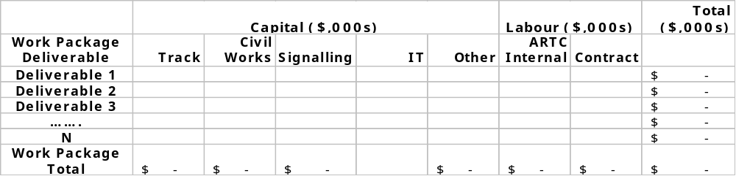
The Work Package Budget should describe the overall costs of the Work Package broken down by deliverable. This spreadsheet is also supported by a budget and cash flow analysis (see below).
When planning the work package in detail these estimates must be derived from a detailed work breakdown structure (WBS) and task level estimates. These are then aggregated together to determine the cost of producing each deliverable. i.e. ‘bottom up’ and must be relatively accurate. (+/-5%)
The budget tolerances for this Work Package are + $X,000/-$Y,000

Work Package Solution
A preliminary Work Package Schedule is to be included as an Appendix to this plan.
Summarise the salient points from the schedule here. This should include:
- The time tolerances for this Work Package are + X Days/-Y Days
- Key dates for start and end of each deliverable
- Key deliverable and overall work package approval points.
- Summary of the critical path for the work package
- Any other schedule related comments
Include a summary of the Work Package Gantt Chart or reference the Gantt Chart as an Appendix

<<Insert a Summary of the Gantt chart here = = =>>

Resource Summary
The <Work Package> internal and contract project resource utilisation is summarised in the attached table:
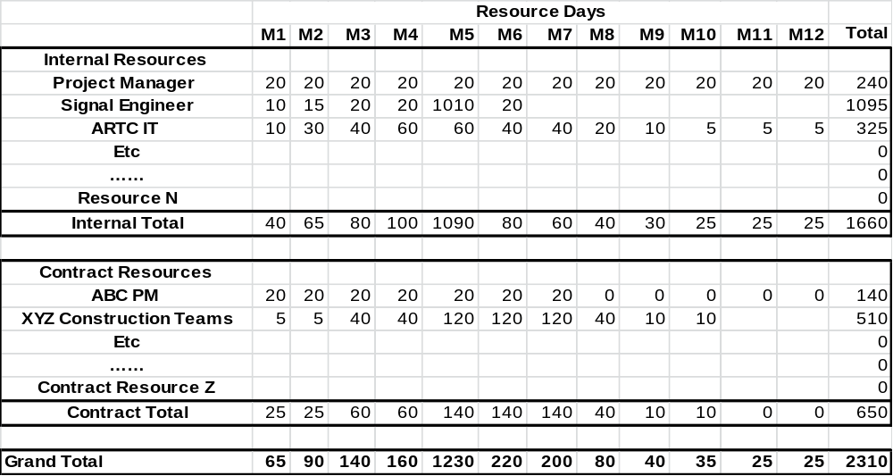

Add narrative here to explain in general terms the resourcing of the work package. These estimates should aim for +/-5% accuracy. Consider:
- Overall resource projections
- Rationale for internal versus contractor use
- Any other relevant resourcing comments pertaining to the work package
Relevant qualifications and assumptions used to derive the estimates.

Work Package Risks
Summarise key risks in this Work Package and reference the overall Project/Stage Risk Assessment.
Summarise the major mitigation activities required for the major risks pertaining to the work package and which individuals or teams are responsible for carrying them out.

